

Aerocats UFB Funding Request Report

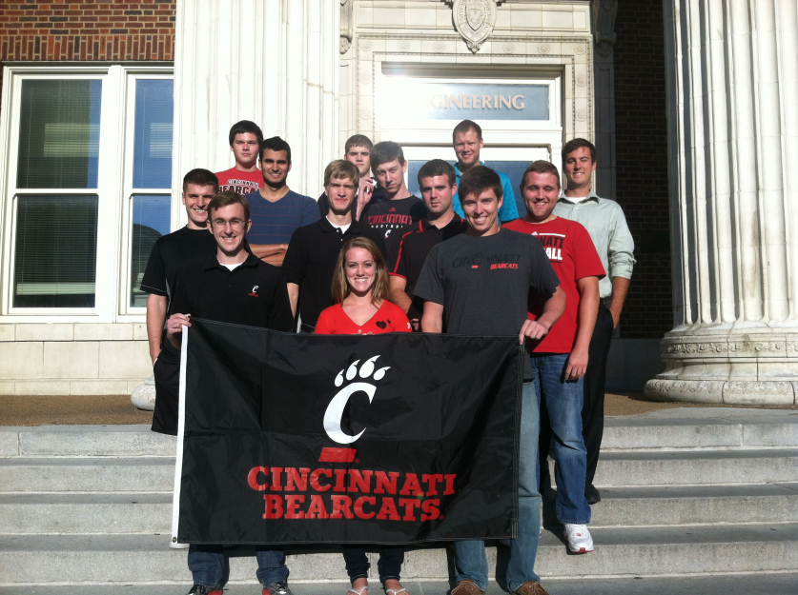

2014-2015 Team: Alejandro Gonzalez, Andre Boisseneault, Andrew Stubblebine, Andy Clemens, Bo Landess, Briana Davis, Christine Weaver, Drew Mayuex, Jake Keller, Josh Combs, Matt Wyborski, Mike McMahon, Patrick Spoltman, Scott Smith, and TJ Schweiterman

2014-2015 Advisor: Mark Fellows

The Aerocats are proud to represent the University of Cincinnati in international collegiate competition. The Aerocats funding request for the upcoming academic year will include a description of our team, what we do, our past performances, and some notes on the teams finances. This year, the Aerocats are requesting that the UFB funds remain the same for next year’s team. Aerocats are the University of Cincinnati’s Competitive Aircraft Design Team. We compete with other colleges from around the world at the SAE Aero Design Competition. The 2015 SAE Aero Design Competition – East will be from March 13-15th in Lakeland, Florida. Our team is comprised of UC students, the team advisor, and our competition pilot.

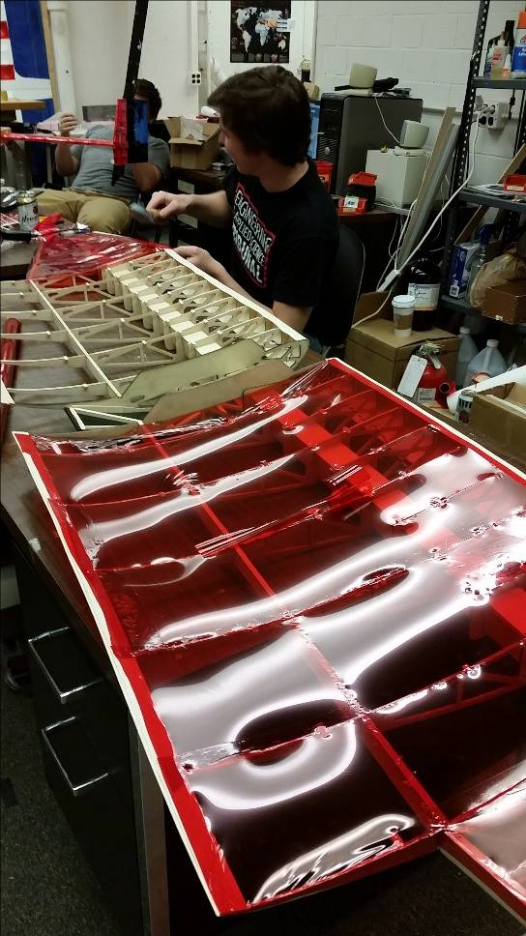This year the Aerocats will design one aircraft to compete in the SAE regular class competition. This class has historically been the most competitive of the classes in the SAE Design Competition. The aircraft must be ran electrically. The total weight of the plane, including its payload, must be less than 55 pounds. It must also have a length, width, and height sum of less than 175 inches. The Aerocats team will be judged on the design report submitted in January, an oral presentation given at the beginning of the competition, and its flight performance during the competition.

Students Spent Hours on Construction and Testing

The University of Cincinnati Aerocats have exhibited a tradition of prowess in the SAE competition for years. The construction of the aircraft is the culmination of hard work through studies and co-op at UC. This team has historically found great success as we are consistently one of the top ranking teams in the world. Table 1 shows the results our team has had in the past few years with top 6 placed teams highlighted in yellow and top 3 teams highlighted in green. We expect to win the regular class 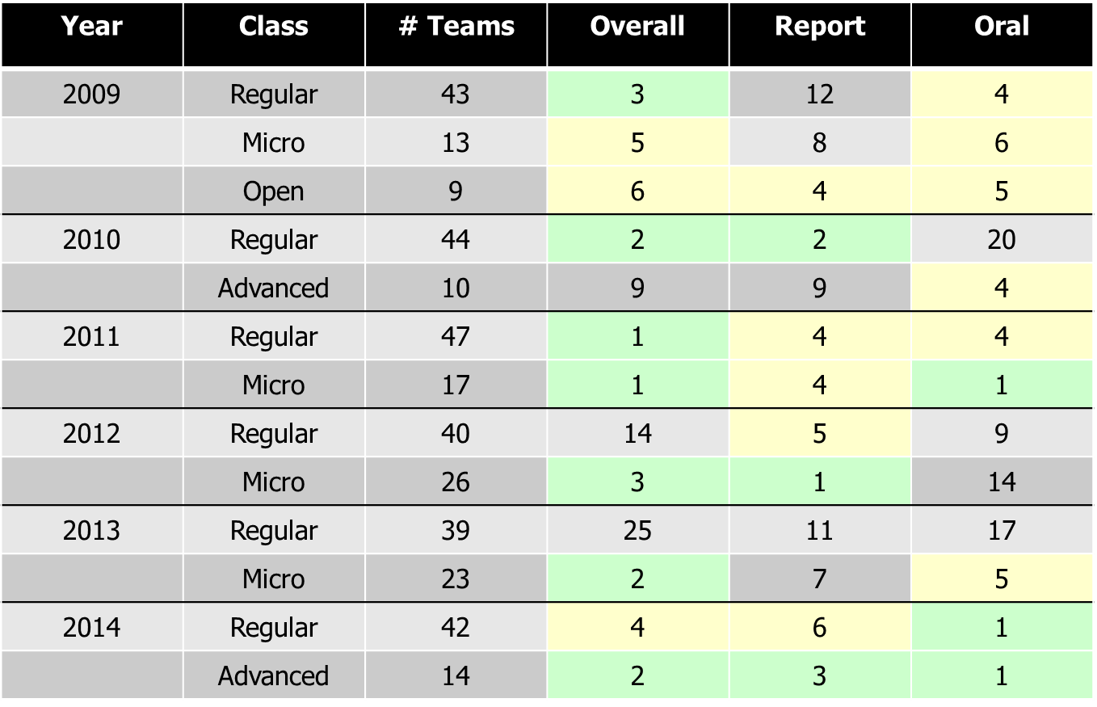competition this weekend.

Table 1: UC Aerocats Competition History

Last year the Aerocats were able to fund a team in both the regular class and advanced class division through the generosity of the UFB and corporate sponsorships. The UFB gave the team $8,000 and the team was able to raise an addition $13,750, allowing them to have enough funds to sponsor two teams. The expenditures included $10,400 for materials to construct the two competition aircraft; $1,400 for the registration of both teams; $2,000 for the team’s lodging; $3,500 for transportation to and from the competition; and $500 for team gear. The grand total for last year’s team budget was $19,800.

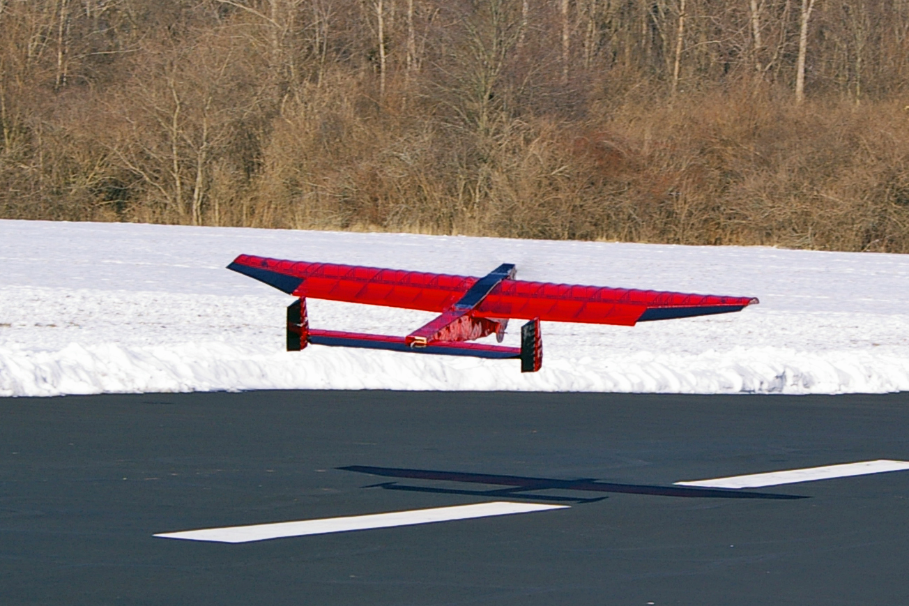Although the Aerocats do not intend on competing in any new competitions, the location changes from year to year and affects how much money is needed for travel. This year the competition was almost twice as far from Cincinnati and our team was almost twice as large as last year. This year’s team only acquired $8,500 from corporate sponsorships and donations. These corporate sponsorships and donations included: $3,000 from 2013-2014 fundraising, $5,000 from Belcan, $250 from ATK, and $250 from Kinetic Vision. These changes led the team to only submit an aircraft for the regular class to ensure that enough funds could go towards the proper materials for testing and constructing the aircraft. This year the team has budgeted to spend $750 for the team registration, $7,800 for travel, $4,000 for materials, and $3,600 for miscellaneous cost. The registration cost is set by SAE International. The travel costs includes van rental, gas for the drive to Lakeland and back, plane tickets for our advisor and pilot, and miscellaneous transportation costs. The $4,000 for materials covers a wide variety of items used to construct the aircraft. The materials include, but are not limited to: wood, wood glue, monokote, propellers, motors, wires, servos to control the moving surfaces, batteries to run the electronics, safety equipment, and an electrical limiter. The grand total for this year’s budget is $16,425.

Students Traveled to Dayton to Test Fly Completed Designs

The Aerocats are requesting the allotted funds for the team be $9,000 again. The Aerocats student group is the best way for engineers to get a hands-on experience in aircraft design and testing. The lessons learned from participating in the planning, analytical designing, testing, constructing, and flight testing is invaluable. Not only does the Aerocats provide this amazing opportunity at UC, but we do fantastic at competition year after year. Every year, teams take time to stop by the UC plane to see what progressive ideas have been brought to the competition and to check out our beautiful design and construction work. Past years have shown that each aircraft class to be entered in competition can cost around $5,000 to $6,000 in material costs and registration fees. The travel cost vary from year to year depending on the number of students traveling and the location of the competition. The sizeable funds provided by UFB make traveling and paying for competition possible. With the funds provided by UFB, and increased fund raising in future years the Aerocats can re-invest time and money into more than one aircraft per competition. We would not have been able to make it all the way across the country to represent our school without UFB support this year. The Aerocats would be honored to continue to represent and win recognition for the #HottestCollegeInAmerica.

Please find the required officer and advisor signatures below:

President: _____________________________________________________________________

(Christine Weaver)

Treasurer: ____________________________________________________________________

(Scott Smith)

Advisor: ______________________________________________________________________

(Mark Fellows)